

User Guide

Version 9.3.0

April 2024

About this guide

This guide documents the user interface of the charting library’s most extensively developed template, technical-analysis-chart.html (formerly sample-template-advanced.html). See an [example implementation](https://demo.chartiq.com/) of the template on the ChartIQ demo site.

Library templates are HTML files that implement various capabilities of the ChartIQ library. The templates simplify and accelerate the development process. Developers can include the templates in their applications as is, extract code snippets from the template files, or just examine and learn from the template source code.

The user interface of technical-analysis-chart.html provides access to all standard features of the charting library.

In addition, technical-analysis-chart.html has been designed to easily include add-on products that are not part of the standard charting library. This guide also documents those add-ons.

# Audience

The ChartIQ User Guide is intended for chart users, such as data analysts. Software developers should see the [ChartIQ library documentation](https://documentation.chartiq.com/).

What’s New

Version 9.3.0 of the charting library introduces the following features and enhancements found in this guide:

* Y-Axis Menus
* Consolidated Events

To find the new features, search for ***NEW v9.3.0***

# Contents

Audience 2

Contents 3

Chart User Interface 8

Responsive Display UI 9

Symbol lookup 10

Comparisons 11

Drawing 13

Drawing palette 13

Create a drawing 13

Drawing modes 14

Smart Drawings 14

Magnet 14

Manage drawings 14

Drawing palette controls 16

Drawing tools 18

Keyboard shortcuts 20

Favorites 21

Style palette 21

Style palette controls 21

Crosshairs 23

Info display 24

Table view 26

Chart Type menu 27

Periodicity menu 28

Views menu 28

Studies menu 29

Study parameters dialog 31

Study legends 33

Drag and drop 34

Study Browser 34

Events menu 38

SIGNALIQ 38

CHART EVENTS 39

PANEL EVENTS 40

Preferences menu 41

CHART PREFERENCES 41

Extended Hours 42

Market Depth 42

L2 Heat Map 43

Y-AXIS PREFERENCES 43

Log Scale 43

Invert 44

ADDITIONAL FEATURES 44

IMPORT DATA 46

THEMES 47

LOCALE 48

Share 50

Time frame selector 52

Navigation 52

Panning 52

Zooming 52

SmartZoom 53

Full-screen display 53

Hidden outliers 53

Study panels 55

Multiple y-axes 55

Y-Axis Menus 57

Drag and drop 57

Series 58

Procedures 58

Y-Axis 59

Procedures 59

Add-on features 61

Multi-Chart 61

Select the grid size 61

Change a chart symbol and periodicity 62

Solo Mode 63

Chart Management 63

Interactive Help 65

Accessibility 65

Chart area 65

Drawing 68

Dialogs & UI Controls 69

Optional Products 70

Active Trader + Trade From Chart 70

Life Cycle Events 70

View life cycle events 71

View event information 71

Event zoom 72

Subevents 73

Event Consolidation 74

SignalIQ 74

Technical Analysis: Data Forecasting 75

Term Structure 76

Term Structure user interface 78

Entity lookup 79

Calendar 79

Instrument value 80

Crosshairs 80

Preferences 81

OPTIONS 81

Shading 81

X-Axis Scaling 81

Update Animations 82

Show Update Stamp 82

Recent Updates 83

Set Highlight Duration 84

Timeline Date Selector 84

Menus 86

Toolbar 86

Y-Axis 87

THEMES 87

Compare 87

Add an entity curve 88

Add an historical curve 88

Plots display 89

Remove curves 90

Change curve color 90

Curve spreads 90

Varying instrument sets 91

Share 92

Zoom 92

# Chart User Interface

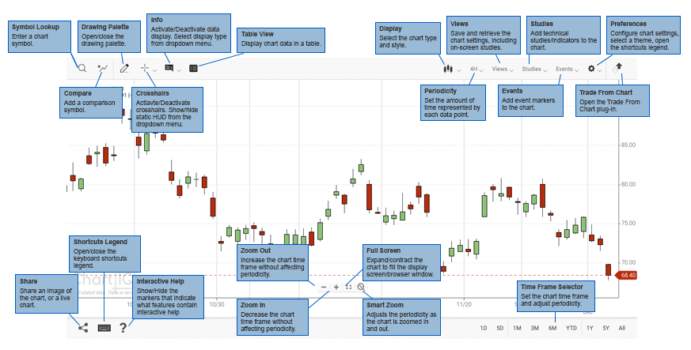

# Responsive Display UI

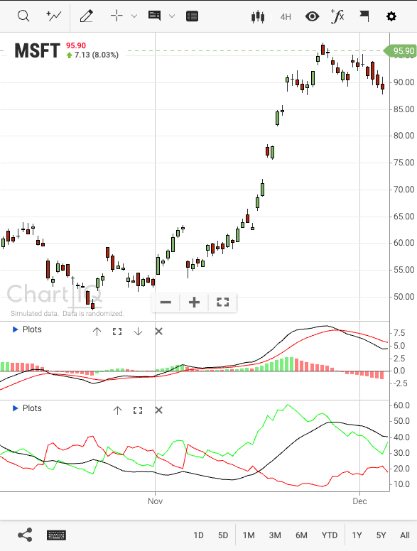

# Symbol lookup



Use the symbol lookup field to find instruments (stocks, currency exchange rates, indexes, and so forth) by entering the symbol that represents the instrument.

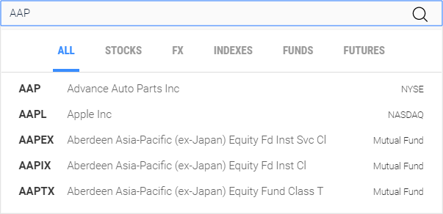  
Figure. Search dialog.

To find an instrument or symbol:

1. Select the magnifying glass icon or select the symbol name on the chart.
2. Select one of the instrument categories (**STOCKS**, **FX**, **INDEXES**, **FUNDS**, or **FUTURES**) to limit your search. To search all categories of instruments, select **ALL**.
3. Enter the instrument symbol (“AAP” in the example above).

As you enter a symbol, the list of instruments is refined to successively approximate the input.

1. Select an instrument from the list, or press **Enter** to select the symbol in the text input field.

# 

# Comparisons

Comparison series are plots of instruments in addition to the main chart series. Comparisons provide a side-by-side look at different instruments. Comparison series are plotted over the same time frame, using the same periodicity as the main series, but are displayed in a different style or color. Your chart can include numerous comparisons.

**Note:** Comparisons change the chart y-axis values to percentages. The time series plots and the y-axis are adjusted so that all plots start at 0% (at the left side of the chart). Succeeding data is plotted as the relative change from 0%. When all comparison series are removed from the chart, the y-axis reverts to its normal type of values.

To compare an instrument to the main chart series:

1. Select the compare icon (upper left corner of the chart) 
2. Enter the instrument’s symbol in the symbol lookup window
3. Optionally, select a color you would like to use for the comparison

A plot for the instrument is drawn on the chart (purple line):

**Figure.** Comparison series overlaid on chart.

To see information about the comparison plot, move your mouse over the **Plots** control (upper left corner of the chart):

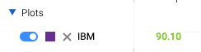  
Figure. Comparison display on the legend.

To close the Plots display, move your mouse away from the control.

To keep the Plots display open, select the **Plots** control. Select the control again to close the display.

Click the color swatch on the legend to change the comparison color.

To remove the comparison, select the **X** next to the instrument’s current price.

To manage the comparison, move your mouse over the instrument’s line on the chart:

* Right-click the line to delete the comparison.
  + In mobile-responsive view, tap the comparison once to display a trashcan icon. Tap the trashcan icon to delete the comparison.
* Click and hold the line until the drag iconappears, and then drag the line to the top or bottom of the chart to place the line in its own panel. See the Drag and drop section to learn about additional drag-and-drop capabilities.
  + In mobile-responsive view, long-hold the comparison line until the rest of the chart goes dim, and then drag the line to the top or bottom of the chart to place the line in its own panel.

# Drawing



Trend lines, average lines, channels, Fibonacci retracements, arrows, callouts, doodles — an extensive set of drawing and styling tools enable you to creatively highlight and graphically analyze charts and studies.

|  |  |
| --- | --- |
|  | Drawing palette The drawing palette contains a wide variety of drawing tools along with a collection of controls used to configure the palette and manage drawings. (See Drawing palette controls and Drawing tools.)  Select the **Draw** control  to open the drawing palette. Create a drawing To draw on a chart or study:   1. Select a tool from the palette.   On desktop browsers, crosshairs appear, indicating the position of the tool.   1. Click or press to begin the drawing. (Release the mouse button or lift your finger or stylus from the screen.)   On touch devices, crosshairs appear, indicating the starting point of the drawing; the crosshairs are positioned slightly up and to the left of your finger or stylus.   1. Move the mouse or your finger or stylus to the endpoint of the drawing. 2. Click or press to end the drawing.   On touch devices, the crosshairs move to the endpoint of the drawing.  In default drawing mode (see below), the **No Tool**  control will activate after a single drawing is made |

## Drawing modes

Drawing is accomplished in one of two ways (or modes) depending on your system’s configuration:

* **Default mode** — As described above in “Create a drawing,” the default drawing mode uses clicks or presses to begin and end the drawing process. Default mode gives you precise control over the placement and size of drawings. In addition, default mode enables the creation of complex drawings, such as channels, that are defined with more than two clicks or presses.
* **Drag to draw** — Drag to draw mode enables you to create drawings by clicking or pressing, holding, and dragging — like drawing in most paint programs. Drag to draw is familiar to most users but lacks the precision of default mode and does not support multiple-point drawings.

## Smart Drawings

Drawings will automatically attach themselves to any series or study that the mouse is hovering over before the drawing is started. Hence, if the series or study is moved to another panel, the drawing moves with it, preserving its position. Similarly, if the study or series is removed from or re-added to the chart, the drawing will be removed/re-added.

## Magnet



Click the magnet icon at the bottom of the palette to make the drawing tools lock onto specific values of the data series. When magnet mode is on, a blue bullet follows the data series to show the value currently selected. The drawing tools are magnetized to the series to which the mouse is closest. As you move the mouse close to another series, the drawing tools magnetize to that series. If a drawing is started on a series, the drawing tool is magnetized to the same series to finish the drawing.

## Manage drawings

Drawings can be repositioned and resized by drag-and-drop interactions. Drag and drop a drawing to move it to another location. Drag the start and end points of a drawing to change the drawing’s shape and size. To reveal the start and end points of a drawing, hover your mouse over the drawing; on touch devices, tap the drawing.

**Note:** Drawings scale across different periodicities.

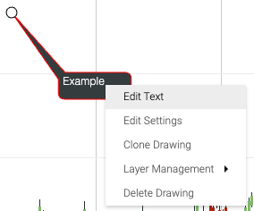

Figure. Right-click context menu for a callout drawing.

To edit or delete a drawing on desktop browsers right-click the drawing to access a context menu, which provides the following options:

* **Edit Settings** — Accesses the style palette (see Style palette), which enables configuration of font, color, and other style settings.
* Edit Text — Allows text changes for drawings that contain text.
* **Clone Drawing** — Creates a copy of the drawing, which can be applied elsewhere on the chart, study, or series.
* **Layer Management** — Positions overlapping drawings on the z-axis, relative to one another. Brings a drawing forward or sends it backward, moves it to the top or bottom of a stack of drawings.
* **Delete Drawing** — Removes the drawing from the display.

On touch devices:

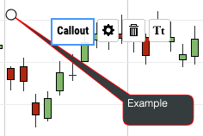  
Figure. Single-tap menu for callout drawing on mobile-responsive.

* Tap the drawing once to highlight it, then tap the trashcan icon to remove the drawing.
* To edit the drawing settings, tap the drawing to highlight it, then tap the settings icon to open the style palette.

## Drawing palette controls

|  |  |
| --- | --- |
| Control | Description |
|  | Displays the drawing tools in a list view. |
|  | Displays the drawing tools in a grid view. |
|  | Detaches the palette from the side of the screen, making the palette draggable anywhere on-screen.  Drag the detached palette using the drag strip  at the top of the palette.  Dock the palette by selecting the Attach control. |
|  | Deselects the current drawing tool; that is, sets the palette so that no drawing tool is in use. |
|  | Enables measurements of the chart, study, or series area. Select the measure tool, then draw a line on the chart to measure an area. |
|  | Undoes drawing actions. |
|  | Restores drawing actions removed by Undo. |
|  | Enables selection of subsets of the drawing tools, such as text tools, statistics-related tools, and favorites (see Favorites). |
|  | Causes a drawing tool to be attracted to a line, such as the main chart series, a comparison series, or a study. Magnetizing a tool to a line provides precise placement of the drawing on the line. |
|  | Removes all drawings from the display. |
|  | Restores all drawing settings to their default values. Tool settings can be changed using the style palette (see Style palette). |

## Drawing tools

|  |  |  |
| --- | --- | --- |
| Text |  | Annotation |
|  | Callout |
| Statistics |  | Average Line  Average line drawings can be applied to any rendered series or study line, not just the primary series. |
|  | Measurement Line |
|  | Quadrant Lines |
|  | Regression Line — Option to show 1st, 2nd, and 3rd standard deviation lines on the regression drawings. |
|  | Tirone Levels |
|  | Volume Profile by Date Range |
| Technicals |  | Gann Fan |
|  | Gartley |
|  | Pitchfork |
| Technicals |  | Speed Resistance Arc |
|  | Speed Resistance Line |
|  | Time Cycle |
|  | Elliott Wave (see Drawing Elliott Waves below) |
| Lines |  | Channel |
|  | Continuous |
|  | Crossline |
|  | Doodle |
|  | Horizontal Line |
|  | Line |
|  | Ray |
|  | Trend Line |
|  | Vertical Line |
| Fibonacci |  | Fibonacci Retracement |
|  | Fibonacci Projection |
|  | Fibonacci Arc |
|  | Fibonacci Fan |
|  | Fibonacci Time Zone |
| Markings |  | Ellipse |
|  | Rectangle |
|  | Arrow |
|  | Check |
|  | Cross |
|  | Focus |
|  | Heart |
|  | Star |

## Keyboard shortcuts

Drawing tools can be activated by keyboard shortcuts. See the Accessibility section for details.

## Favorites

You can reduce the number of tools displayed on the drawing palette by creating a set of your favorites.

When the list view of the palette is active (see Drawing palette controls), a star appears next to each of the drawing tools. Select the star to mark the tool as one of your favorites and pin it to the top position in the tool list.

In grid view on desktop browsers, right-click a tool to open a pop-up window, then click the pop-up window to add or remove the tool as a favorite. Favorites are indicated by a star ornament in grid view.

To see only your favorites, select **Favorites** from the drawing palette dropdown menu.

## Style palette



The style palette appears when a drawing tool is selected. The palette contains controls that enable you to set properties of the drawing tool, such as background color, line width, and font.

Properties vary among tools. For example, the annotation tool has font properties, but does not have background color or line width; the ellipse tool has background color and line width, but not font properties.

### Style palette controls

|  |  |
| --- | --- |
| Control | Description |
|  | Detaches the palette from the top of the screen, making the palette draggable anywhere on-screen.  Drag the detached palette using the drag strip on the left side of the palette.  Dock the palette by selecting the Attach control. |
|  | Identifies the currently selected tool (to which the styles apply). |
|  | Sets the fill of the drawing. Selecting “NONE” will render the fill transparent. |
|  | Sets the line/stroke color of the drawing. |
|  | Sets the line width and line style of the drawing. |
|  | Sets the font in italics. |
|  | Sets the font in boldface. |
|  | Specifies the size of the font. |
|  | Specifies the font family. |
|  | Saves the style palette settings (the configuration) of the selected tool. The tool retains the configuration even after the chart is closed.  To restore the tool’s default configuration, select the X next to the Save Config control. |

# Crosshairs



Select the crosshairs icon  to show horizontal and vertical lines that follow the mouse. Crosshairs enable you to easily identify values on the x- and y-axes.

The crosshairs can optionally show a heads-up display (HUD) of information for the data point targeted by the crosshairs. The HUD is shown and hidden by the dropdown menu adjacent to the crosshairs icon.

***NEW v9.1.2*** Drag the HUD to move it to a different location.

Figure. Crosshairs with HUD visible.

# 

# Info display



Select the Info icon to show detailed information about individual data points. The default display shows, date, price, open, high, low, close, and volume. Data points are selected by moving the mouse over the time series.

The Info display can be a dynamic callout or tooltip. The display type is selected from the dropdown menu next to the Info display icon. ***NEW v9.1.2*** The default choice for the Info button is the tooltip.

**Note:** The dynamic callout is not available on mobile devices.

The dynamic callout appears next to each data point as the user’s mouse moves over the chart.

**Figure**. Info dynamic callout.

The tooltip follows the user’s mouse across the chart, but the associated data point is indicated by a vertical highlight (or the crosshairs, if active).

*NEW v9.1.2* The information displayed in the tooltip will correspond with the information conveyed by the active chart type.

**Figure**. Info tooltip.

# Table view



The Table view add-on creates an on-screen table that contains the same information as the graphical chart display, including study and comparison data. Table view enhances chart accessibility by enabling screen readers to read the line and study content shown on the chart.

Figure. Chart data, including comparison and study.

To open the table view, select the **Table View** button. 

To copy the table data to the clipboard, select the **Copy** button.

To export the table data to a comma-separated values file, select the **Download** button.

To display (and hide) data for Volume, % Change, and % Change vs Average, select the **Additional columns** button. A plus sign (+) appears on the button when the additional columns will be shown; a minus sign (-), when the columns will be hidden.

# Chart Type menu

The **Chart Type** menu is divided into two sections: Chart Types and Aggregated Types. 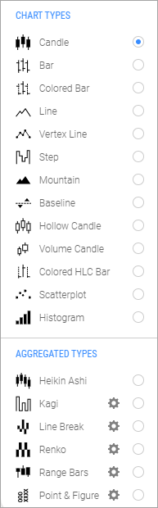

The charting library supports a variety of chart types. Select a type to change the presentation of the time series data.

Chart types are the various ways that a chart can visually represent data; for example, as a candle, line, or mountain graph.

Aggregated types are charts that display data that has been modified through aggregation or recalculation; for example, Heikin Ashi, Kagi, and Point & Figure charts.

To customize a chart type:

1. Select the gear icon next to the chart type name.
2. Enter values in the dialog box that appears. For example, for Kagi charts:

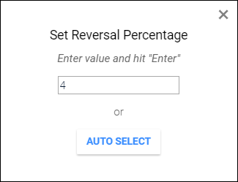

Select the **AUTO SELECT** button to let the chart determine the setting.

For more information on chart styles and types, see the *ChartIQ Charts and Studies* guide.

# Periodicity menu

Periodicity is the amount of time represented by a data point (for example, a candle on a candle chart).

Select the chart periodicity from the **Periodicity** menu. Periodicity can be multiples of seconds, minutes, hours, days, weeks, or months.

# Views menu

A view is the chart display, including all technical studies/indicators, chart type, periodicity, and chart preferences. Use the **Views** menu to save chart views for later retrieval.

To save a view, select **+ Save View and submit a typed name.**

To retrieve a saved view, select the view (for example, My Saved View) from the list of views.

To delete a saved view, select the **X** next to the view name.

# Studies menu

Studies are technical indicators that you add to charts from the **Studies** menu. For a complete list of the studies included in the ChartIQ library, see the *Charts and Studies* guide.

To add a study to a chart, select the study from the **Studies** menu.

To quickly find a study, enter the study name in the search field. As you enter the name, the list of studies is reduced to just those names that include the characters you entered.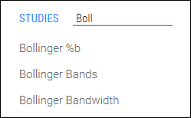

Studies can overlay charts or appear in panels above or below charts. By default, some studies appear as overlays, and some appear in panels.

Overlays (and underlays, such as the Volume Underlay study) are studies that are superimposed on charts.

**Figure.** Alligator study overlaid on chart with the studies menu visible.

Overlay studies include a context menu that can be used to modify the study or remove it from the chart. To access the context menu:

* On desktop browsers — Highlight the study by hovering your mouse over the lines or shapes that make up the study. Right-click to open the context menu. Select an item from the menu.

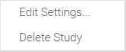

* On touch devices — Tap the study to open the context menu. Tap the gear icon to edit study properties. Tap the **X** icon to delete the study.



Studies can appear in panels to separate the displays of multiple series.

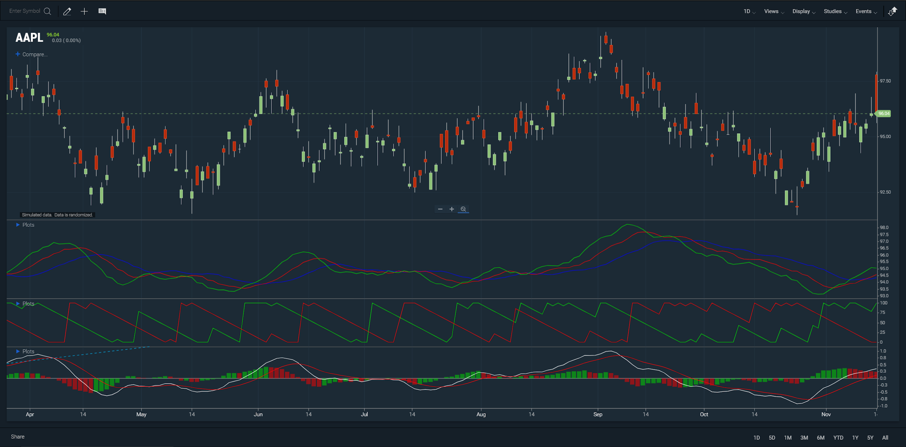

**Figure.** Alligator, Aroon, and MACD studies in panels.

The vertical size of panels can be changed by dragging the panel top and bottom borders.

Panels include a toolbar that can be used to reposition or delete the panel. On desktop browsers, hover your mouse over a study to reveal the toolbar:



Secondary panel toolbar controls

|  |  |
| --- | --- |
|  | Moves the panel upward in a stack of panels. If the panel is at the top of the stack, positions the panel above the chart. |
|  | Expands the panel and hides any other panels. Or, if the panel has been expanded, returns it to its former size and reveals all hidden panels. |
|  | Moves the panel downward in a stack of panels. If the panel is at the bottom of the stack, positions the panel below the chart. |
|  | Closes the panel and destroys the study. |

Drawings and annotations can be applied to overlay studies and studies in panels using the Drawing palette and Style palette tools.

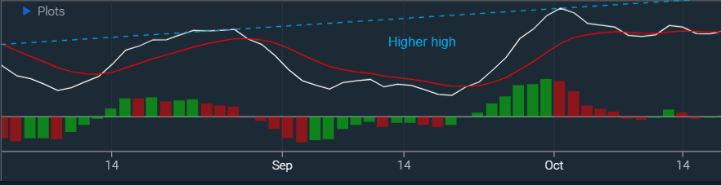

**Figure**. Dashed line and annotation on MACD study in panel.

## Study parameters dialog

Many settings can be adjusted in each study. Below are descriptions of common parameters that appear in many studies:

|  |  |
| --- | --- |
| Period | Specifies the number of bars incorporated in the study’s calculation. |
| Field | Specifies the input series for the study calculation. Users can select from different components of price bars (open, high, low, close, adjusted close), or calculations of those components (hl/2, hlc/3…). Users may also select from studies that are currently on the chart. Users may also select from comparison series that are currently on the chart. ***NEW v9.0*** |
| Type | Specifies the type of Moving Average incorporated in the study’s calculation. |
| Color Picker | Specifies the color of the study output on the chart. |
| Panel | Specifies which chart panel the study appears in. Panels are listed in vertical order as they appear on the chart. |
| Show as Underlay | Sets the study behind the main study or series in its panel. |
| Y-Axis | Specifies where and how the study’s Y-axis appears in the panel. |
| Invert Y-Axis | Flips the Y-axis upside-down. |

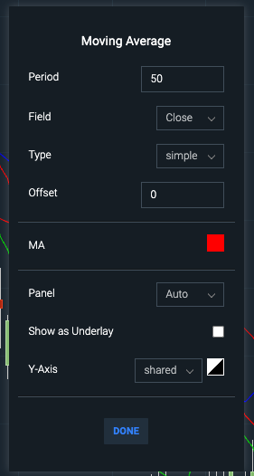  
Figure. A moving average study dialog.

## Study legends

A list of the studies applied to a chart is overlaid on the chart as a legend. The list of active studies is contained in the CURRENT STUDIES section of the **Studies** menu, and in the Plots control, which appears on study panels or on charts when one or more studies overlays the chart.

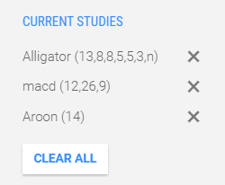  
Figure. A list of the active studies in the Studies menu.

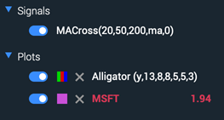  
Figure. The expanded view of the Signals and Plots legends.

Study plots and signals can be quickly switched on/off from the study legend, eliminating the need to go to a menu.

CURRENT STUDIES and Plots both enable you to edit and delete studies.

In CURRENT STUDIES, edit a study by selecting it from the list. Delete a study by selecting the **X** icon next to the study name. Delete all studies by selecting **CLEAR ALL**.

In Plots, press anywhere on the study item to edit the study dialog. Select the **X** icon to delete the study.

## Drag and drop

Studies can be positioned and managed by drag-and-drop user interactions. Overlay studies can be dragged into panels. Studies in panels can be dragged onto charts as overlays. Studies can be combined in panels or on charts. See Drag and drop for more information.

## Study Browser

For Technical Analysis package holders, the studies menu is replaced with the Study Browser.

**Figure**. The Study Browser viewing all studies

The Study Browser sorts studies into categories that can be navigated, including a Most Popular category, and a Favorites category.

Studies can be filtered by text using the search field at the top of list in Study Library.

Studies can be marked as favorites. Studies marked as favorites are promoted to the top of the Study Library list as well as their respective categories. Multiples of the same study can be added as favorites. Studies that contain different parameters from the default will have their parameters displayed in the Favorites category. Studies that are on the chart can be added as favorites by right-clicking the study and selecting “Add to Favorites”.

Active studies can be viewed by going to Active Studies. Clicking on a study in this menu will close the Study Browser and display the study dialog for that study. Clear All will erase all studies from the chart.

**Figure**. Active Studies section showing an active Alligator study

Educational material about studies can be accessed by highlighting a study and selecting the Information icon. The educational section contains a short description of the study, a star to favorite the study, an Add Study button, and a back arrow to return to the list.

**Figure.** Educational section of Study Browser displaying Alligator study

Note: The study browser is not used on touch devices, but the favoriting capability is preserved.

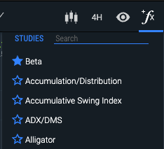  
Figure. Study Browser’s favoriting capability is preserved on touch devices.

# Events menu

The Events menu enables you to display visual indicators of:

* time-based events such as stock splits, dividend dates, financial filings, earning reports, and news events
* custom signals that appear when specific conditions are met for studies interacting with the primary series.

The indicators mark the date and time of an event. You can then select the indicator to see a description of the event or even a video related to the event.

## SIGNALIQ

The SignalIQ section enables users to define signal events based on technical study patterns. For more information, see SignalIQ under Optional Products.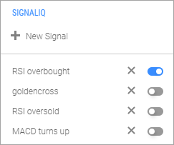

To display study event signals, select the slider for the ones you want to view.

To delete a saved signal, select the **X** next to the signal name.

To create a signal:

1. Open the **Events** menu.
2. Select **+** **New Signal** in the **SIGNALIQ** section.
3. Configure the signal by creating conditions in the **New Signal** dialog:
4. Choose a study from the dropdown list; click the cogwheel icon (Shape

   Description automatically generated with low confidence) to edit the study.
5. In the first row of the condition:

* Select the first study component that will generate the signal (e.g., **MA 1**).
* Select the event that will generate the signal (e.g., **Crosses Above**).
* Select the second study component to compare to the first (e.g., **MA 3**).

1. In the second row of the condition:
2. Select the signal type: Chart Marker, Paintbar, or Emoji Marker.
3. Choose the signal color from the color palette.
4. Select the marker shape: **Circle**, **Diamond**, **Square**, or **Text**.
5. Add a marker label either by typing any keyboard character in the box or (by choosing an emoji in the emoji picker.
6. Select the marker size.
7. Select the marker position relative to the primary series (e.g., **Above Line**).
8. Optionally, add a description that will appear when the signal is clicked.   
   Note: emojis can be added to description using shortcodes (e.g., :smile: = 😊).
9. Click the plus button to add additional conditions as desired.
10. Name and save the new signal.

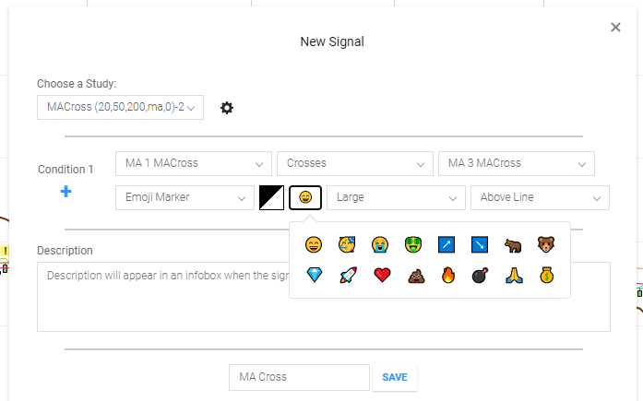  
Figure. New Signal dialog filled out.

## CHART EVENTS

The Chart Events section enables you to display visual indicators of time-based events such as stock splits, dividend dates, financial filings, earning reports, news events, and more.

The indicators mark the date and time of an event. You can then select the indicator to see a description of the event or even a video related to the event.

To display event indicators, select the slider for the ones you want to view: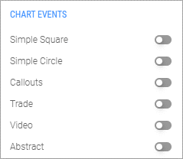

* Simple Square — Marks events with a colored square and a letter that indicates the type of event
* Simple Circle — Marks events with a colored circle and a letter that indicates the type of event
* Callouts — Indicates events with a short text description or title
* Trade — Displays a small, filled circle at the data point where a trading event has occurred
* Video — Displays a video playback button to mark events
* Abstract — Indicates events with an image or animation

## PANEL EVENTS

The **PANEL EVENTS** section of the menu applies to Life Cycle Events. See the Life Cycle Events section to learn more.

# Preferences menu

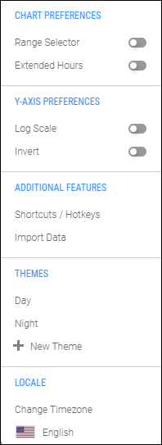

Open the **Preferences** menu by selecting the cog wheel control. The menu enables you to set a variety of preferences to display your charts just the way you want them.

To set a preference, select the slider next to the preference name.

## CHART PREFERENCES

Range Selector

The Range Selector preference opens a panel below the chart. The panel contains more data history than is shown in the primary chart. Drag the controllers in the range selector to control the viewable range of time in the primary chart.

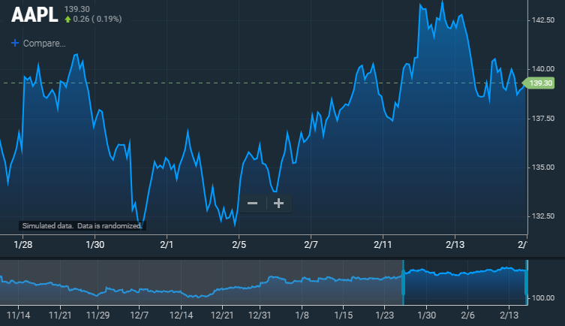  
Figure. Chart with range selector visible.

|  |  |
| --- | --- |
| Extended Hours The Extended Hours preference expands the trading hours of intraday charts to include pre- and post-session trading for U.S. equities. The pre- and post-sessions are highlighted with background shading. Extended hours are particularly useful for observing trading activity during earnings season. | Figure. Chart with extended hours visible. |

|  |  |
| --- | --- |
| Market Depth (Only available with the Trade From Charts plug-in.)  The market depth display shows histograms of the volume of bids and asks at each price level if Level 2 data is provided. In addition, it shows an aggregate volume up/down from the current market to a given price. The graphic helps users understand if there is more pressure above or below the market. | Figure. Chart with market depth visible. |
| L2 Heat Map (Only available with the Trade From Charts plug-in.)  The heat map shows an overlay of the Bid/Ask depth of market at the close of the period. That is, for a one-minute chart it will show the volume on the bid at each price level in green and volume on the offer in red at each price level. | Figure. Chart with L2 Heat Map visible |

## Y-AXIS PREFERENCES

Y-axis preferences enable you to configure the chart y-axis on a logarithmic scale or invert the price values.

|  |  |
| --- | --- |
| Log Scale On a logarithmic scale chart, the vertical spacing between two points corresponds to the percentage change between those numbers. Thus, on a log scale chart, the vertical distance between 10 and 20 (a 100% increase) is the same as the vertical distance between 50 and 100. Because these charts show percentage relationships, logarithmic scaling is also called percentage scaling. It is also called semi-log scaling because only the vertical axis is scaled logarithmically.  Charts automatically switch from a log scale to a standard y-axis when the data set includes y-axis values that are less than or equal to zero. The log scale is restored when the chart is refreshed, or new data is retrieved. | Figure. Chart with log scale active. |
| Invert Inverting the y-axis simply flips the chart to display the lowest values at the top and highest values at the bottom. This will flip the primary line and any drawings or overlay studies applied to the line. **Note:** Each study line which is shown in its own panel may be flipped independently. | Figure. Chart with invert active. |

## ADDITIONAL FEATURES

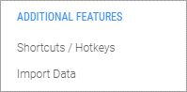Shortcuts / Hotkeys

Shortcuts and hotkeys make chart functionality accessible from the keyboard (see Accessibility). The shortcuts legend displays all keyboard shortcuts and hotkeys.

To open the legend, either select **Shortcuts / Hotkeys** from the ADDITIONAL FEATURES section of the **Preferences** menu or click the keyboard icon () in the footer.

The shortcuts legend is a moveable, resizable window that can be minimized and dragged anywhere within the browser window, including outside the chart.

**Figure**. Shortcuts legend.

## IMPORT DATA

The Import Data feature enables you to import files in CSV format and add them to a chart as data for a main or secondary series.

To import data:

1. Select **Import Data** in the ADDITIONAL FEATURES section of the **Preferences** menu.
2. In the **Import Data** dialog, select the **Choose Files** button.
3. Navigate to the file location, select the file(s) you want to import, and then click **Open**.   
   The box shows the number of files chosen for import.  
     
   Graphical user interface, text, application

   Description automatically generated
4. Click **OPEN FILES**.   
   The Import Data dialog containing details of the imported file(s) appears.

Figure. Import data dialog.

1. Modify the name for the imported data, set the desired periodicity, check the headers, and choose to display data as either the primary or secondary series.

Themes set the foreground and background colors of the chart. The two built-in themes, Day and Night, set charts in light and dark colors, respectively.

To choose a theme, select it from the THEMES section of the **Preferences** menu.

You can also create your own custom themes.

To create a custom theme:

1. Open the **Preferences** menu.
2. Select **+** **New Theme** in the **THEMES** section.
3. Configure the theme by making color selections in the **Create Custom Theme** dialog box:

Figure. Custom theme dialog.

1. Enter a name for your theme in the input field, and then select **SAVE**.

Your theme will be listed in the THEMES section of the Preferences menu. To apply your theme to a chart, select it from the menu.

The locale settings enable you to present the user interface in a variety of languages and apply any time zone to the chart data.

To choose a language:

1. Select the current language setting; for example, 
2. Select a language from the **Choose language** dialog box:

Figure. Language Menu.

To change the time zone:

1. Select Change Timezone
2. Select a time zone from the **Choose Timezone** dialog box

Figure. Timezone menu.

If the current time zone is different than that of your current location, the  control appears in the dialog box. Select the control to set the time zone to your current location.

# Share

The Share feature enables you to either a) share a live chart or b) create an image of a chart. Both of these features generate a link that may be shared on Twitter or Microsoft Teams ***NEW v9.0***

***NEW v9.0*** To share a live chart:

1. Select the **Share** control at the bottom of the chart.

Select the Live Chart button.  
 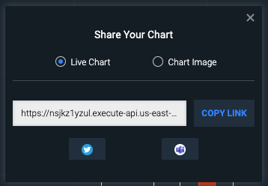  
Figure. Share dialog for a live chart.

1. Select the **COPY LINK** button.
2. Paste the link into any ChartIQ chart to view the live chart.

To share a chart image:

1. Select the **Share** control at the bottom of the chart.

Select the Chart Image button in the Share Your Chart dialog box.   
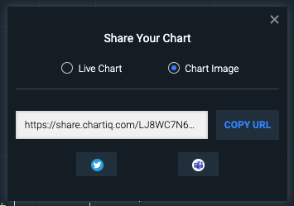  
Figure. Share dialog for chart image.

1. Select the COPY URL button.
2. Paste your link into email message, documents, or texts to enable access to your chart image.

***NEW v9.0*** To Share to Twitter:

1. Click the Twitter icon. You will be redirected to Twitter and prompted to log in if not already logged in.
2. A message will be generated with the link prepopulated.

***NEW v9.0*** To Share to Microsoft Teams:

1. Click the Microsoft Teams icon.
2. Enter the emails of the recipients of the link.
3. Click the SHARE button to be redirected to Teams.

# Time frame selector



The time frame selector (lower right corner of the chart) enables you to select various time periods for the chart — from one day to all the data available for the instrument.

Each selection automatically sets an appropriate periodicity so that the chart is filled with data. For example, if you select the **1D** time frame, the periodicity is set to 5 minutes; **6M**, one day; **All**, one month; and so forth.

# Navigation

In general, navigation of the chart is easily done using direct manipulation or using controls provided.

## Panning

A chart is panned (scrolled) by dragging the chart. When a chart is panned so that the most recent bar is hidden, a home icon appears on the screen. Pressing the icon animates the chart back to the home position.

On desktop devices, grab the chart with the mouse and drag it left, right, up, or down.

The right and left arrow keys and Home and End keys also pan the chart (see Accessibility).

On laptop touchpads, a two-finger horizontal stroke will pan the chart left or right. On all devices, a swipe action will rapidly scroll the chart in the swipe direction, slowing with an easing animation.

On a touch device, a single finger touch will move the chart from side-to-side or up and down. When the crosshair is enabled, two fingers can be used to pan the chart.

## Zooming

To zoom the entire chart, select the  and  buttons at the bottom of the chart;  to zoom in,  to zoom out.

On touch devices, pinch the screen to zoom out, press the screen with two fingers then spread the fingers apart to zoom in.

The up and down arrow keys also zoom the chart (see Accessibility).

The scale of the x- and y-axes can be zoomed by selecting either axis and dragging up or down for the y-axis or left or right for the x-axis.

## SmartZoom



SmartZoom automatically changes the periodicity of the chart to maintain visual density of the data as you zoom the chart in and out. SmartZoom enables you to quickly go from one-second to yearly data increments and keep the chart packed with data.

To activate SmartZoom, select the SmartZoom control  (at the bottom of the chart).

The SmartZoom control appears only when the chart is configured to use the feature.

## Full-screen display



The full-screen control enlarges the chart to fill the entire display area, hiding the browser chrome and removing the chart’s top and bottom toolbars. Full-screen display provides a productive, uncluttered viewing experience on screens of all sizes.

On desktops, expand the chart to full screen by selecting the  control (at the bottom of the chart). Exit full-screen mode by selecting the control again, by pressing F11, or by pressing the Esc key.

## Hidden outliers

Data sets often contain outliers: values that deviate significantly from the statistical norm.

With the hidden outliers feature, outliers are literally off the chart. Visual markers alert users to the presence of outliers and provide the interactive option of seeing the outlying portions of the chart.

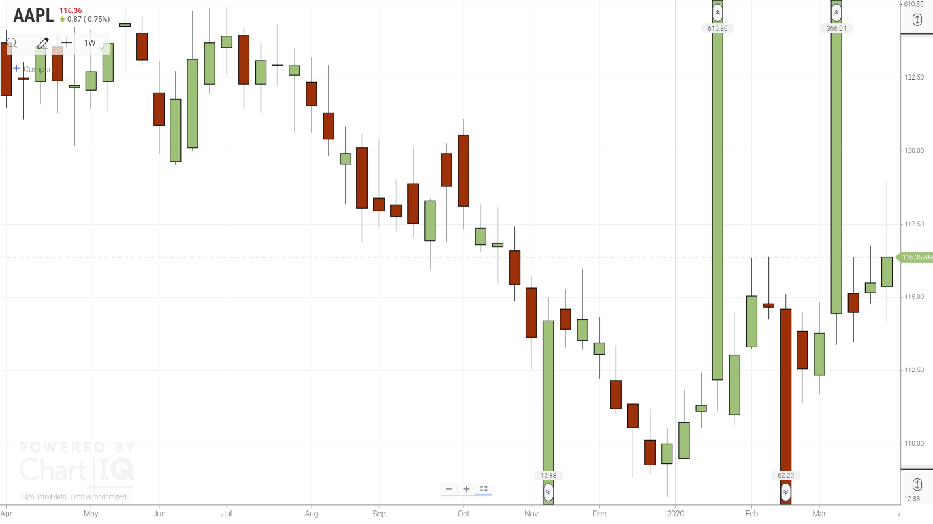  
**Figure.** Chart with hidden outliers.

To activate the hidden outliers feature, open the **Preferences** menu and select **Hide Outliers** from the **CHART PREFERENCES** section:

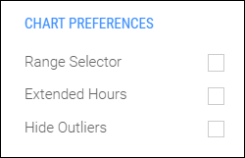

**Note:** The Outliers add-on must be included in your charting application in order to appear in the CHART PREFERENCES menu.

The upper outlier  and lower outlier  markers indicate the position of high or low outlier values. Select either type of marker to reveal the full range of the upper or lower portion of the chart, respectively.

Complementary controls appear in the upper and lower right corners of the screen.

Select the show control  in either corner (upper or lower) to show the respective outlying portion of the chart.

Select the hide control hide  to hide the outliers.

### Study panels

Outliers can be hidden in study panels as well as the primary panel. When a chart has outliers, studies associated with the chart may have outliers too. The outliers cause display problems: the study lines, channels, or bars get compressed to fit into the display area, reducing detail.

Study outliers can be hidden—replaced by markers   that indicate the outlier location and value—making the study data trend clear. The markers can be selected to reveal the outliers. Controls at the top and bottom of the study’s y-axis also show and hide the outliers.

**Figure.** Momentum Indicator with hidden outliers.

### Multiple y-axes

Hidden outliers are supported on multiple y-axes; for example, when a comparison series has been added to a chart. The outliers for each series can be shown and hidden independently using the outlier controls on the respective y-axis. 

Selecting a high   or low   outlier marker in a series reveals the upper or lower portion of just that series.

**Figure.** Chart with comparison series and hidden outliers.

# Y-Axis Menus

Y-axes display an ellipse menu (…) when hovered over, or when the series associated with the axis is hovered over. ***NEW v9.3.0*** Available actions will display depending on the number of Y-axes, their merged status, and their relative position.

|  |  |
| --- | --- |
| Move Left/Right | Swaps the position of the selected axis with an adjacent axis. If the selected axis is bordering the chart panel, Move Left/Right will send the axis to the other side of the chart panel. |
| Merge Left/Right | Merges the selected axis with an adjacent axis on the same side of the chart panel.  NOTE: Axes cannot be merged across the chart panel. |
| Unmerge | Separates the selected axis into its constituent axes. |

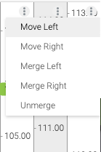  
**Figure**. Axes can be moved, or merged/unmerged on the same side of the chart panel.

# Drag and drop

Charting elements such as y-axes and series (studies and comparison) can be positioned and manipulated using drag-and-drop user interactions.

To drag and drop a charting element, do the following:

1. Click and hold or press the element until one of the drag-and-drop icons appears. The icon indicates the direction in which the element can be dragged:

|  |  |
| --- | --- |
|  | — Horizontally |
|  | — Vertically |
|  | — All directions |

1. Drag the element to a container or boundary.

Charts, panels, and axes are containers. The edges of charts, panels, and axes are boundaries.

A blue rectangle appears when you drag to a container. A blue line appears when you drag to a boundary. The rectangle or line indicates the drop location.

**Note:** A blue rectangle or line must appear before you can drop an element. At the screen edges, be careful to drag and drop within the charting area. The drag-and-drop icon turns to the default pointer or disappears when you drag an element out of the charting area. If you drop an element outside the charting area, the drag-and-drop action does not take effect.

1. Drop the element by releasing the mouse button or lifting your finger or stylus from the screen.

## Series

Study and comparison series overlay charts or appear in panels above or below charts.

Series can be managed with drag and drop. Overlays can be dragged into panels. Series in panels can be dragged onto charts as overlays. Series can be combined. The y-axis of a series can be positioned to the left or right of the series.

### Procedures

**Convert Overlay Series to Panel Series** — Drag and drop an overlay series onto a chart boundary or panel boundary.

**Convert Panel Series to Overlay Series** — Drag and drop a panel series onto a chart.

**Combine Series** — Drag and drop multiple overlay series or panel series into a single panel. Or drag and drop series from multiple panels onto a chart.

**Uncombine Series** — Drag and drop a series from a panel (containing multiple series) onto a panel boundary or chart boundary or onto a chart. Or drag and drop an overlay series (from a chart containing multiple overlays) onto a chart boundary or panel boundary.

**Position Panel Series** — Drag and drop a panel series onto a chart boundary or panel boundary.

**Position Y-Axis** — Drag and drop the y-axis of a series onto the left or right boundary of the series. Or drag and drop the series onto its own left or right boundary. See the Y-Axis section below for additional features.

## Y-Axis

The y-axis of charts and series can be positioned on the left or right of the chart or series, or on the left or right of other y-axes. Multiple y-axes can be combined into a single axis. All by drag and drop.

Multiple y-axes occupy the same chart or panel when charts are overlaid by series or series are combined in panels.

### Procedures

**Position Y-Axis on Left or Right of Chart** — Drag and drop the chart y-axis onto the left or right boundary of the chart.

**Position Y-Axis on Left or Right of Series** — Drag and drop a series y-axis onto the left or right boundary of the series. Or drag and drop a series onto its own left or right boundary.

**Position Y-Axis on Left or Right of Another Y-Axis** — Drag and drop a y-axis onto the left or right boundary of another y-axis. Or drag and drop a series onto the left or right boundary of a y-axis contained in the same panel or chart.

**Combine Y-Axes** — Drag and drop a y-axis onto another y-axis. Or drag and drop a series onto a y-axis contained in the same panel or chart.

**Uncombine Y-Axes** — Drag and drop a series (whose y-axis is combined with another y-axis) onto its own left or right boundary or onto the boundary of a y-axis contained in the same panel or chart.

# Add-on features

## Multi-Chart

The Multi-Chart template displays up to 25 charts in a grid layout, enabling you to make side-by-side comparisons of multiple instruments and markets. The grid is designed to maximize the screen real estate devoted to the charts and minimize the number of on-screen controls and borders.

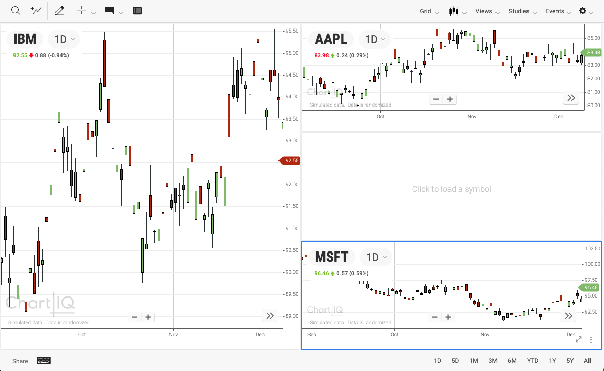  
**Figure.** Grid of multiple charts.

Each chart displays its own time series data, periodicity, and **studies**. The active chart is indicated by a border, and will respond to actions made on the toolbar (e.g., study additions, chart type changes, etc). If crosshairs are toggled on, they will activate on the chart that is being hovered over, regardless of which chart is active.

### Select the grid size

The Grid control enables you to select the size of the chart grid. There are grid templates to choose from, or the ability to make a custom grid. The custom grid control is similar to graphical controls used to create tables in word processors.

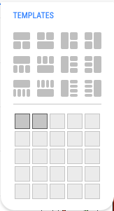  
Figure. The Grid menu.

To create a custom chart grid:

1. Select the Grid control (release the mouse button)
2. Move your mouse down and to the right to expand the grid, up and to the left to contract the grid
3. Click the control to set the size of the grid

Note: Charts in a grid are arranged in a set order. This order is preserved when the grid undergoes changes in its arrangement.

### Change a chart symbol and periodicity

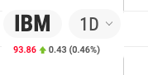  
Figure. Symbol and periodicity displayed on a multi-chart chart.

Each chart in the grid displays a time series that is independent of the other charts. The symbol and periodicity are displayed on the chart. These can both be changed by selecting the symbol title to launch a Symbol Lookup dialog, or selecting the periodicity to launch a periodicity selection menu.

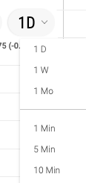  
Figure. Periodicity Selection menu.

### Solo Mode



Each chart in the grid displays a Solo mode button when hovered over (on touch devices, Solo mode is always visible). Selecting the solo mode button will make the selected chart the active chart, and expand it to cover all of the other charts. Select the solo mode button again to restore the chart to its previous size.

### Chart Management



Each chart in the grid displays an ellipse button when hovered over (on touch devices, ellipse button is always visible). Selecting the ellipse button reveals a menu that allows changes in the chart grid in reference to the active chart.

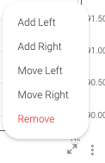  
Figure. The chart management menu.

Adding a chart left/right will insert a chart into the previous/next slot of the grid order. Depending on how the charts are arranged in the selected template, this means that a chart may be added above/below the active chart if the charts are arranged vertically, or to the left/right if they are arranged horizontally.

Moving a chart left/right will swap the active chart’s position with the next/previous chart in the grid order.

Selecting Remove deletes the active chart from the grid order, causing the remaining charts to rearrange.

# Interactive Help

Additional information about features can be accessed by long-pressing on the applicable features. Clicking the  Interactive Help icon will place markers on the features that contain interactive help.

Note: The interactive help markers do not need to be visible in order to trigger interactive help on any feature.

# Accessibility

Keystroke alternatives provide access to chart functionality without using a mouse or touchscreen.

## Chart area

|  |  |
| --- | --- |
| **Keystroke** | **Functionality** |
| =, or + on numeric keypad | X-axis zoom in |
| - (hyphen), or - (minus) on numeric keypad | X-axis zoom out |
| + (Shift + equal) | Y-axis zoom in (if pressed on numeric keypad, x-axis zoom in) |
| _ (Shift + hyphen) | Y-axis zoom out |
| Right arrow* | Scroll chart right one bar or, if crosshairs enabled, move crosshairs one bar right |
| Left arrow* | Scroll chart left one bar or, if crosshairs enabled, move crosshairs one bar left |
| Up Arrow* | Scroll chart up 2% of the chart height or, if crosshairs enabled, move crosshairs up 2% of chart height |
| Down Arrow* | Scroll chart down 2% of the chart height or, if crosshairs enabled, move crosshairs down 2% of chart height |
| Shift + Right Arrow* | Scroll chart right 10 bars or, if crosshairs enabled, move crosshairs right 10 bars |
| Shift + Left Arrow* | Scroll chart left 10 bars or, if crosshairs enabled, move crosshairs left 10 bars |
| Shift + Up Arrow* | Scroll chart up 20% of the chart height or, if crosshairs enabled, move crosshairs up 20% of chart height |
| Shift + Down Arrow* | Scroll chart down 20% of the chart height or, if crosshairs enabled, move crosshairs down 20% of chart height |
| Page Up or Alt + Right Arrow | Scroll chart right by the maximum number of bars on screen |
| Page Down or Alt + Left Arrow | Scroll chart left by the maximum number of bars on screen |
| Home | Scroll to the end of the chart (right-most candle) and reset the vertical zoom |
| End | Scroll to the beginning of the chart (left-most candle) as loaded  **Note:** If the chart is using a quote feed, more data loads |
| Delete or Backspace | Undo the active drawing (if in the process of drawing) or delete a highlighted item |
| Escape | Undo the active drawing (if in the process of drawing) or close an open menu |
| Tab | Move focus to the next user interface element on the chart, and to browser controls outside of the chart UI such as the address bar |
| Shift + Tab | Move focus to the previous user interface element |
| Enter/Return | Select (activate) the currently focused user interface element |
| Alt + \ | Show/hide the crosshairs and static information display |
| Alt + 0 | Show/hide the continuous zoom (if enabled) |
| Shift + Alt + L | Select the symbol lookup |
| **Add-ons** | |
| Shift + Alt + R | Show/hide the range slider |
| Shift + Alt + X | Show/hide extended hours |
| Shift + Alt + O | Show/hide outliers |
| Shift + Alt + / or  Shift + Alt + ? | Show/hide the keyboard shortcuts legend |
| Alt + K | Show the table view (press the Escape key to hide table view) |
| **Plug-ins** | |
| Shift + Alt + D | Show/hide market depth |
| Shift + Alt + M | Show/hide the L2 heat map |
| Shift + Alt + P | Show/hide Trade From Chart |
| *Values are configurable; and so, may not be the same as the values shown. | |

## Drawing

The example templates (such as *technical-analysis-chart.html* and *basic-chart.html*) include the following keyboard shortcuts for activating drawing tools when the drawing palette is open:

|  |  |  |
| --- | --- | --- |
| **Tool** | **PC** | **Macintosh** |
| Line | Alt + l | Option + l |
| Horizontal (line) | Alt + o | Option + o |
| Vertical (line) | Alt + p | Option + p |
| Annotation | Alt + w | Option + w |
| Rectangle | Alt + r | Option + r |
| Arrow | Alt + a | Option + a |
| Ellipse | Alt + e | Option + e |

**Note:** Do not include the Shift key in the shortcut.

## Dialogs & UI Controls

|  |  |
| --- | --- |
| **Keystroke** | **Functionality** |
| Right/left arrow | Move in dialog elements that support a cursor |
| Escape | Close an open dialog |
| Tab | Move focus to the next dialog or UI control element |
| Shift + Tab | Move focus to the previous dialog or UI control element |
| Enter/Return | Select (activate) the currently focused dialog or UI control element (e.g., open a color palette or press a button) |
| Space | Toggle the currently focused element selection (e.g., turn an option on/off) |

# Optional Products

## Active Trader + Trade From Chart

The Trade From Chart feature within the Active Trader module enables you to construct and execute trades right from the chart. In addition to simple order types such as market orders, the charting library supports construction and execution of complex, multi-leg conditional orders (OCO, OTO, OTO linked to OCO, etc.). With a simple drag-and-drop interface, you can place stop and limit orders with automatically calculated risk/reward ratios. Filled and pending orders can also be plotted on the chart, enabling you to see historical trades, current positions, and pending orders with the ability to click and modify.

The Trade From Chart module works seamlessly across desktop, tablet, and phone, so if an order is placed at your desktop, you can check or modify or replace orders from a mobile device.

## Life Cycle Events

Many events have a life cycle — a beginning, middle, and end; events such as institutional trades (which take hours and comprise multiple transactions), CEO tenures, economic trends, weather events, and so forth. The Life Cycle Events module tracks and graphically displays life cycle events, including ongoing events.

**Note:** Life Cycle Events is a plug-in module; it is not part of the standard product.

Life Cycle Events occur over a span of time. They are depicted on charts in two ways, as a horizontal bar or as an icon followed by a dashed line (or tail). Both depictions show the start, end, and duration of an event.

**Figure.** Chart with life cycle events.

### View life cycle events

Life cycle events are displayed in a panel below the chart. 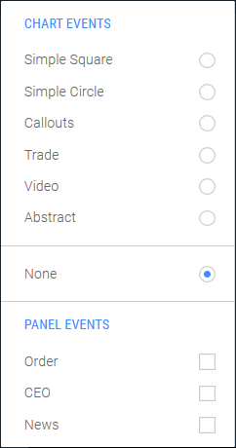

To open the panel:

1. Open the **Events** menu.
2. In the **PANEL EVENTS** section, select the types of events you want to view.

Each event type appears in its own swim lane (horizontal band) of the panel. The y-axis of the panel identifies the swim lanes by event type.

To close the panel:

1. Open the **Events** menu.
2. Clear all check boxes in the **PANEL EVENTS** section.

### View event information

Life cycle events are related to the chart time series. To highlight the time span of a life cycle event on the chart, hover your mouse over the life cycle event marker. Click the marker to make the highlighting remain on-screen. Click the marker again to make the highlighting respond to hovering the mouse.

Hovering the mouse over a single event or duration event displays a tooltip containing the event headline. Selecting an event marker shows the event headline and story in a pop-up display. Select the pop-up display to close it.

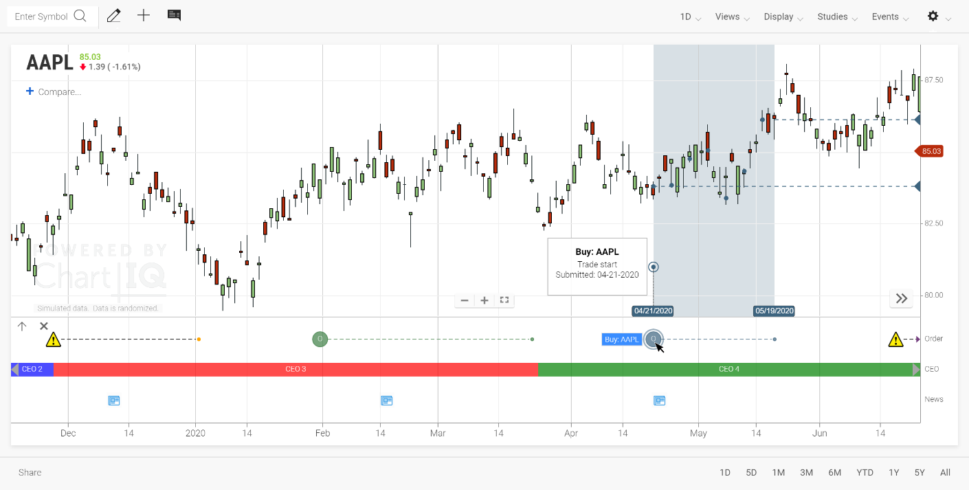  
**Figure.** Highlighted life cycle event time span with tooltip and pop-up display.

Life cycle event markers can be custom icons. For example, an alert icon  could denote events that require special attention.

Life cycle events also indicate when an event is ongoing with a special symbol (such asor ) at the most recent data point for the event.

The highlighting of trade execution events includes horizontal dashed lines that connect the starting and ending trades of an order with values on the y-axis.

### Event zoom

Double click an event in the swim lane to zoom in from a broad periodicity to a finer level of detail to see more granular data. Restore the previous state using the button.

**Figure.** Life cycle events at default periodicity.

**Figure.** Zoomed-in view of a life cycle event.

### Subevents

Life cycle events often have subevents; for example, an institutional order may include multiple trade executions.

To display information about life cycle subevents:

1. Select the life cycle event marker

The time span of the event is highlighted on the chart and any subevents are indicated by a small circular marker.

1. Select a subevent marker

A pop-up display opens, containing information that summarizes the subevent. Select the pop-up display to close it.

**Figure.** Highlighted life cycle event time span with subevent pop-up displays.

### Event Consolidation

***NEW v9.3.0*** Events that fall on the same bar will consolidate into a group marker, which indicates the number of events contained in the marker. Clicking the grouped marker will expand a menu which lists out the events contained.

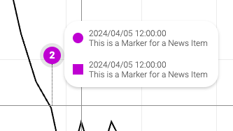  
Figure. A consolidated event marker displays contained events.

## SignalIQ

The SignalIQ plug-in enables chart users to incorporate visual signals highlighting event occurrences in their technical analysis. Unlike alerts, which appear only when they occur and don’t stay on the chart for users to view, SignalIQ uses chart markers and paintbars to display events, which allows users to add signals for historical evaluation as well as ongoing analysis.

You can easily identify and analyze salient market actions by constructing custom rules using any of our available studies. Event signal conditions are defined using any of 11 events (e.g., Is Greater Than, Crosses, Increases, etc.) and marker shape, size, position, and label are customizable.

**Figure.** Chart events appear as circles on the RSI study and diamonds on the chart; green markers show when RSI crosses above 50, yellow markers show when RSI crosses below 50. The panel containing the underlying study can be shown/hidden by clicking a marker highlighted on hover.

## Technical Analysis: Data Forecasting

Data Forecasting enables visualization of predicted trends. Forecasting data is appended to historical data in chart series and studies, extending the series or study into the future. Forecasts can be appended to past dates to show the accuracy of past forecasts. A forecast can include a range of outcomes which may be displayed as a projection cone. Forecasting data can be displayed in a variety of line styles and colors to distinguish the forecast portion of a series or study from the historical data.

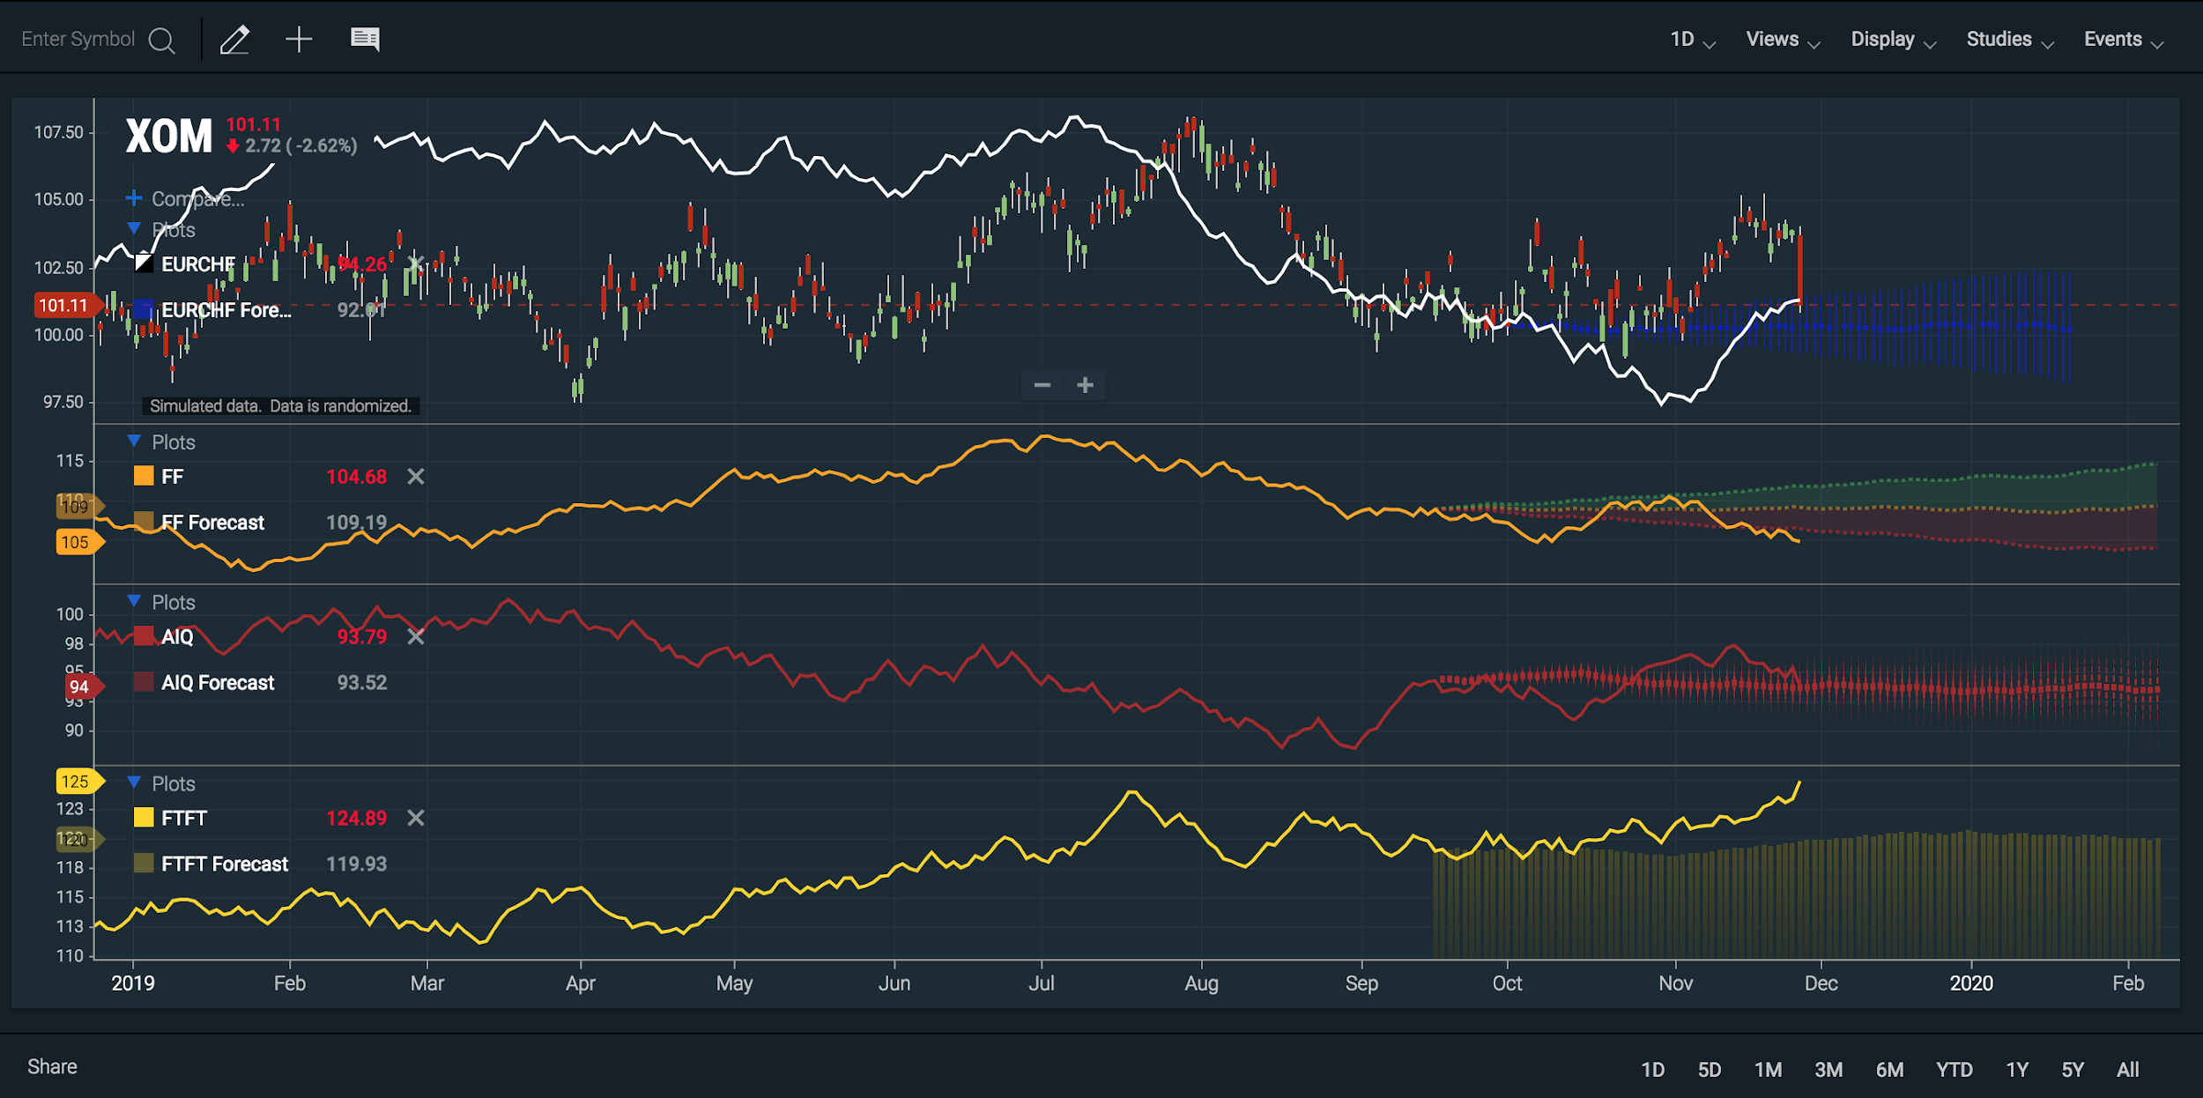  
**Figure.** Multiple plots with forecasts in various styles.

**Note:** Data Forecasting is included in the Technical Analysis package. It is not part of the Core Charts package.

## Term Structure

Term structures are graphs of financial instrument values ordered by date of delivery. An interest rate yield curve is a type of term structure; yield is ordered by maturity date.

The Yield Curve chart compares U.S. Treasury yields at various maturity dates. The curve can display bid or ask prices or the midpoint of the price spread (the difference between the bid and ask) at each maturity date.

The Yield Curve chart can compare multiple series of instruments (creating multiple curves) and display curve spreads: the difference in values between curves and between instruments on the same curve.

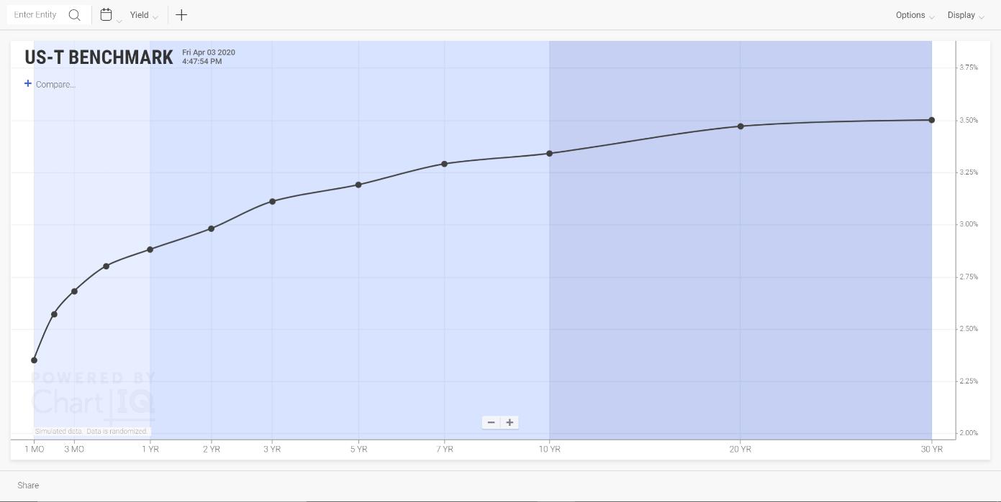  
**Figure.** U.S Treasury yield curve.

**Note:** Term Structure is a standalone package or a plug-in module to the Technical Analysis package; it is not part of the Core Charts package.

### Term Structure user interface

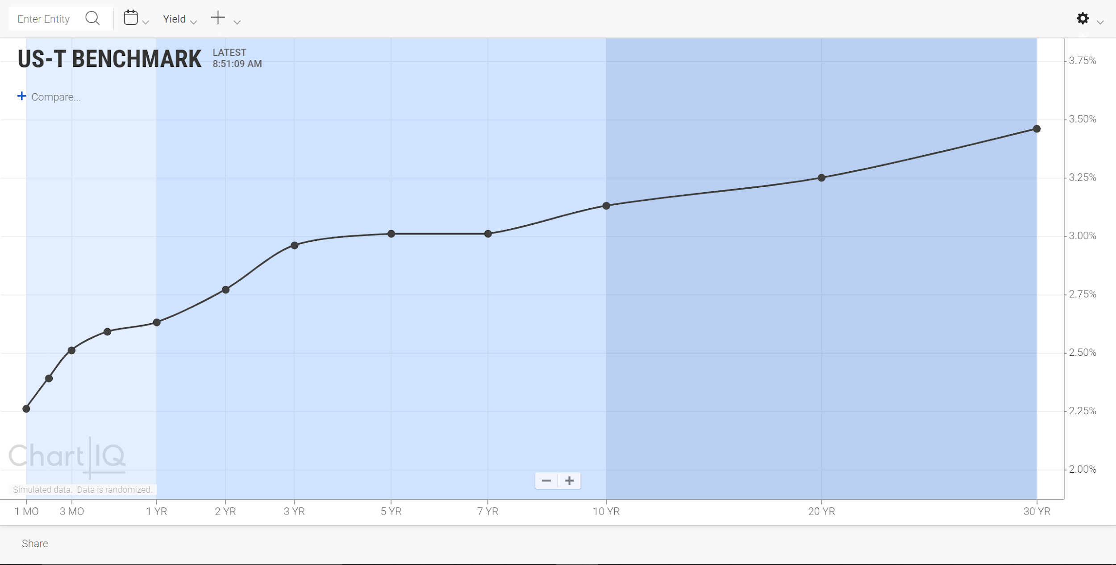

### Entity lookup

Find term structure entities (bond issuers and futures contracts) by entering the symbol that represents the instrument in the entity lookup field.

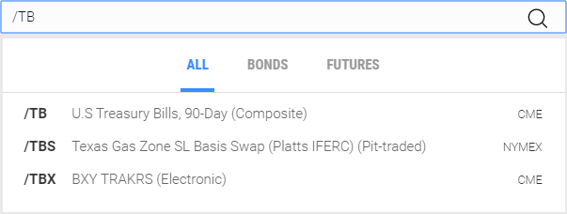  
Figure. Entity lookup dialog.

To find an entity:

1. Select the magnifying glass icon or the entity input field.
2. Select one of the instrument categories (**BONDS** or **FUTURES**) to limit your search. To search all categories of instruments, select **ALL**.
3. Enter the instrument symbol (“/TB” in the example above).

As you enter a symbol, the list of instruments is refined to successively approximate the input.

1. Select an instrument from the list, or press **Enter** to select the symbol in the text input field.

Alternatively, begin typing a symbol anywhere in the chart area; the entity lookup field opens automatically.

### Calendar

Use the calendar to select the date for the term structure. The instrument values for that date are plotted on the chart.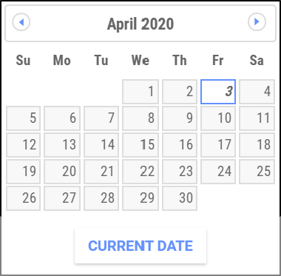

To choose a date:

1. Select the calendar icon  to open the calendar
2. Use the forward and back arrows to scroll the calendar months
3. Select a day of the month or select **CURRENT DATE**.
4. Select the calendar icon to close the calendar

The calendar changes the dates of entity comparison curves along with the date of the primary curve.

### Instrument value

The values of the term structure instruments are plotted on the y-axis.

To select an instrument value:

1. Open the instrument value menu.
2. Select a type of value.

### Crosshairs



Select the crosshairs icon to display crosshairs that follow your mouse and snap to points on the graph.

The crosshairs dropdown menu enables you to show or hide a heads-up display (HUD) that presents data for all curves for the term selected by the crosshairs.  
**Figure.** Term structure chart with historical curves, crosshairs, and HUD.

### Preferences



The **Preferences** menu enables you to configure the look and feel of the chart.

#### OPTIONS

##### Shading

The chart background shading indicates short-, mid-, and long-term delivery dates of the term structure.

Select the **Shading** check box to turn shading on; clear the check box to turn shading off.

##### X-Axis Scaling

The delivery dates of term structure instruments are not always evenly spaced. For example, the bond yield curve includes 1-month, 3-month, 6-month, 1-year, 2-year, 3-year, 5-year, 7-year, 10-year, and 30-year dates.

To help represent the uneven spacing of dates, Term Structure provides scaling of the x-axis; points on the axis are spaced in proportion to the time between dates. The scaling isn’t exact, rather it’s an approximation to give a sense of the intervals between delivery dates.

The chart also provides fixed spacing in which the delivery dates are all spaced evenly regardless of the time between them.

Select the **X-Axis Scaling** check box to turn scaling on; clear the check box to turn scaling off.

##### Update Animations

**Figure.** Animations indicating instrument updates.

The chart can display animations to draw attention to data points that have just been updated.

Select the **Update Animations** check box to turn animations on; clear the check box to turn animations off.

##### Show Update Stamp

**Figure.** Last update time stamp.

Trades and other actions continually change the values plotted for term structure instruments. A time stamp of the most recent update keeps you informed about an instrument’s activity. When your mouse hovers over a data point, a tooltip appears, displaying the date and time of the most recent update.

Select the **Show Update Stamp** check box to turn time stamps on; clear the check box to turn time stamps off.

##### Recent Updates

**Figure.** Recently updated data points highlighted with a diffuse outline.

Term structure charts can highlight data points that have been updated within a specified time span, such as the last 10 minutes. The highlighting helps users quickly spot instruments whose values are actively changing and instruments whose values have gotten stale.

Select the **Recent Updates** check box to turn highlighting on; clear the check box to turn highlighting off.

###### Set Highlight Duration



You can set the time span that determines whether instrument updates are recent, or fresh. Any data point that has been updated within the time span (for example, the last 10 minutes) is highlighted.

1. Select the cog wheel icon  next to **Recent Updates** in the **OPTIONS** section of the **Preferences** menu.
2. Enter a number of minutes in the **Set Highlight Duration** dialog box, and press **Enter**.

To set the default time span (currently, 10 minutes), select **AUTO SELECT**.

##### Timeline Date Selector

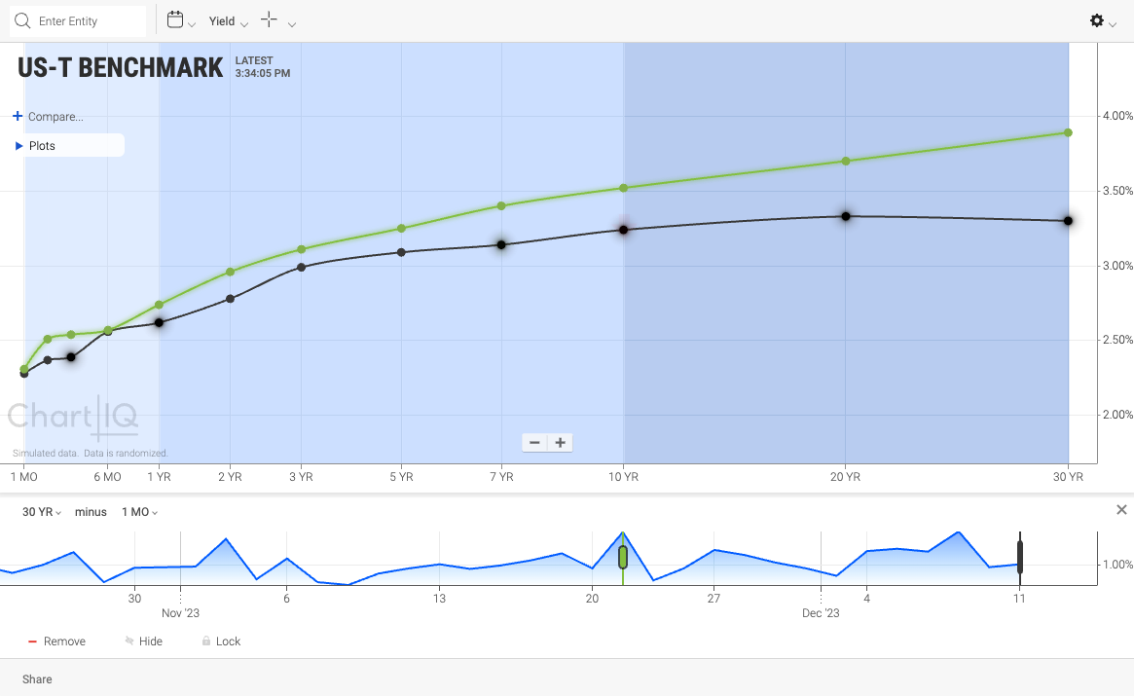  
**Figure.** Term structure chart with Timeline Date Selector.

Term structure charts now have an option to display a Timeline Date Selector, which plots a mountain chart of spreads over time and allows the user to visually select the dates of curves to be displayed. The Timeline Date Selector is activated from the Preferences menu .

The historical data displayed in the Timeline Date Selector is a spread of two points on the curve. In the example of a yield curve, a spread is the difference in yield or price of debt instruments of varying maturities (e.g., the difference in yield between the 10YR and 5YR bonds). Each point of the mountain chart shows the spread between two instruments on a particular date. The instruments for which the spreads are plotted are selected from the Timeline Date Selector dropdown menus.

Handles (slider controls) enable the selection of the dates shown for the main curve and related historical curves. The color of each handle corresponds to the color of the related curve — white (night theme) or black (day theme) indicates the main curve. For example, when the main curve handle is moved to April 26th, the main term structure curve is plotted for April 26th. If a relative historical curve is set at one month before the main curve, the historical curve is plotted for March 26th.

Relative historical curves are locked to the main curve; their dates differ from the date of the main curve by a set amount of time regardless of how the date of the main curve changes. Historical curves can be unlocked from the main curve, and their handles can then be dragged independent of the main curve handle, even ahead of the main curve handle. The date in the plots menu updates as an historical curve handle is dragged.

Any unlocked historical curves are plotted for the date indicated by the position of their handles in the Timeline Date Selector.

Custom historical curves are independent of the main curve when created but can be subsequently locked to the main curve.

Note:

* The Timeline Date Selector chart applies only to the main curve and historical comparison curves. Spreads are not created for entity comparison curves. However, as the main curve handle is moved along the timeline, entity comparison curves (along with the main curve) change to reflect the selected date.
* Additional spread information can be obtained by selecting two points on the main curve, historical curves, or entity curves to see the spread between any two instruments.

###### Menus



Spreads are specified by selecting instruments from the Timeline Date Selector’s dropdown menus.

###### Toolbar

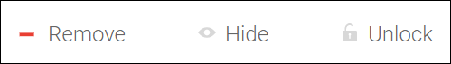

A toolbar below the Timeline Date Selector chart contains the following toggle controls:

**Add/Remove** — Adds an historical curve to the term structure chart or deletes the curve from the chart.

**Show/Hide** — Shows or hides the historical curve on the term structure chart. When the historical curve is hidden, the plot legend item related to the curve and the curve’s handle on the Timeline Date Selector are dimmed.

**Lock/Unlock** — Locks the historical curve chronologically to the main curve, or unlocks the historical curve from the main curve. When the historical curve is unlocked, its handle can be dragged independent of the main curve handle. When the historical curve is locked, the curve handle cannot be dragged; the handle moves in tandem with the main curve handle.

**Note:** The **Add** control appears by default. When an historical curve handle is selected, **Remove** replaces **Add**, and **Show/Hide** and **Lock/Unlock** appear.

###### Y-Axis

The y-axis of the Timeline Date Selector (and term structure chart) can be position on the left or right side of the chart using drag-and-drop.

#### THEMES

Charts can be displayed in different color themes — Day for light colors; Night, for dark.

To choose a theme, open the **Preferences** menu, and then select a theme from the **THEMES** section.

### Compare

The Compare feature enables you to see multiple curves on screen simultaneously.

To add a curve, select the **+ Compare…** control.

The following menu opens:

#### Add an entity curve

Entities are collections of instruments that are comparable to the main curve.

To add an entity to the chart, select **Add Entity** from the **Compare** menu.

The entity lookup dialog box opens:

Figure. Dialog for searching and adding a new entity.

See Entity lookup for information about using the dialog box to select an entity.

To select a color for the entity curve:

1. Select the color swatch. A color picker opens.
2. Select a color from the color picker.

#### Add an historical curve

Historical curves are plotted from past data of the primary entity; in other words, what the main curve looked like a week, a month, or a year ago.

To add an historical curve to the chart, select **Add Historical** from the **Compare** menu.

The **Set Comparison Date** dialog box opens.

To select a color for the historical curve:

1. Select the color swatch. A color picker opens.
2. Select a color from the color picker.

To select a time period for the curve, select a radio button from the list of historical dates.

To select a custom historical data:

1. Select **Custom…**.
2. Select a date from the calendar.

To close the dialog box and create the curve, select **DONE**.

Historical curves are relative to the date of the primary curve. For example, a “1 Week Ago” historical curve will always show data for the previous week relative to the current date, whether the chart is reopened a week, a month, or a year from now. Use the “Custom…” selection to choose a fixed point that will not adjust over time.

#### Plots display

Secondary curves are listed in the Plots display.

To open the display, select the ►**Plots** control:

#### Remove curves

To remove a curve from the chart, select the **X** next to the entry that identifies the curve in the Plots display.

#### Change curve color

1. Select the color swatch next to the entry that identifies the curve in the Plots display.

A color picker opens.

1. Select a color from the color picker.

### Curve spreads

A curve spread is the difference in value between instruments, whether the instruments are on the same curve or on different curves.

To show the spread between instruments:

1. Select one or more data points.

Selected points are indicated by an outer, concentric circle.

1. Hover your mouse over another point.

The spreads are shown by guidelines from data point to data point along with the percent difference. For easy visual reference, the color of the text that shows the spread percentage matches the color of the associated selected data point.

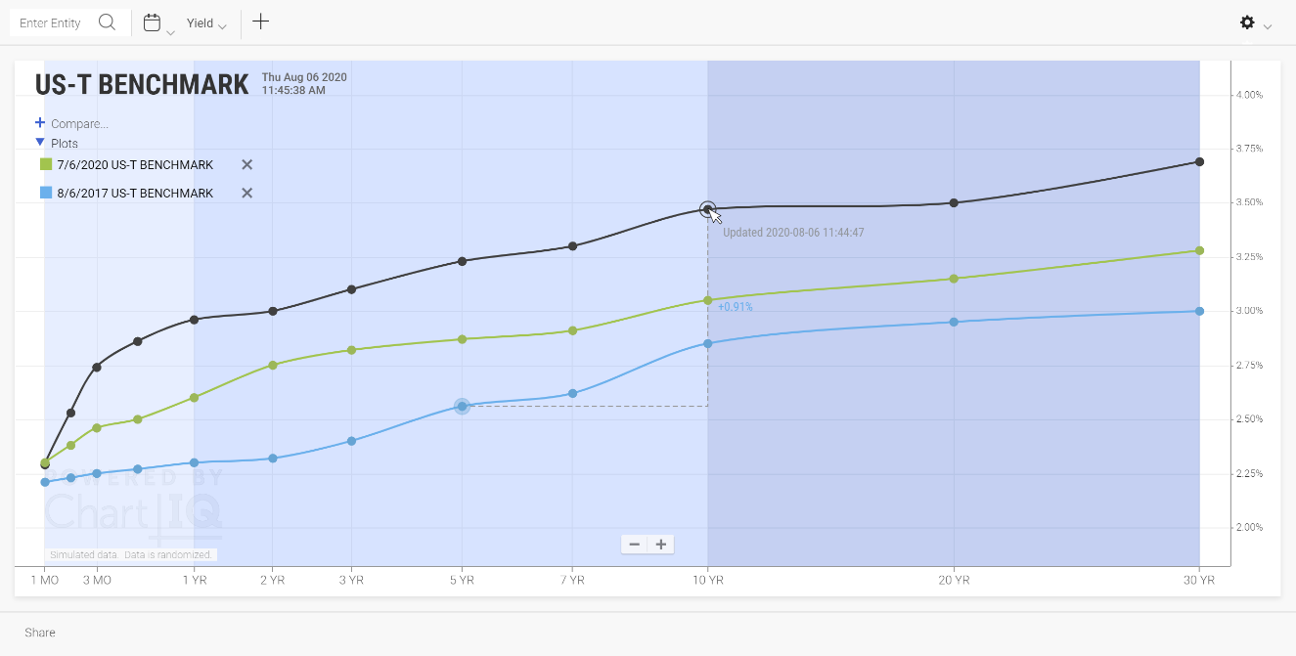

**Figure.** Curve spreads of 5 YR 8/6/2017 and 10 YR 7/6/2020 vs. 10 YR 8/6/2020.

### Varying instrument sets

Term structure charts can display curves for multiple entities when the entities don’t share the same set of maturities for the array of instruments in the curve. For example, the U.S. Treasury yield curve contains maturities (instruments) of 1, 2, 3, and 6 months, but the yield curve of other sovereign bonds may not contain these short-term maturities. Term Structure lets you compare the curves just the same (if the entities have at least one instrument in common).

For each compared entity:

* If instruments are missing on the left or right sides of the chart, the curve is not drawn there.
* If instruments are missing in the middle of the curve, the line is drawn to connect the existing points, but data points are not drawn for the missing instruments.
* If the entity has only one instrument that is shared with the other compared entities, a point is drawn for the instrument (with no line).

**Figure.** Term structure chart comparing entities with varying instrument sets.

### Share

The Share feature enables you to create an image of a chart and share the image from a URL. See Share above.

### Zoom

To zoom the entire chart, select the  and  buttons at the bottom of the chart;  to zoom in,  to zoom out.

On touch devices, pinch the screen to zoom out, press the screen with two fingers then spread the fingers apart to zoom in.

The scale of the x- and y-axes can be zoomed by selecting either axis and dragging up or down for the y-axis or left or right for the x-axis.

The up and down arrow keys also zoom the chart.